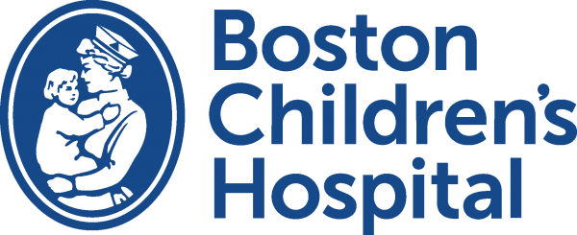
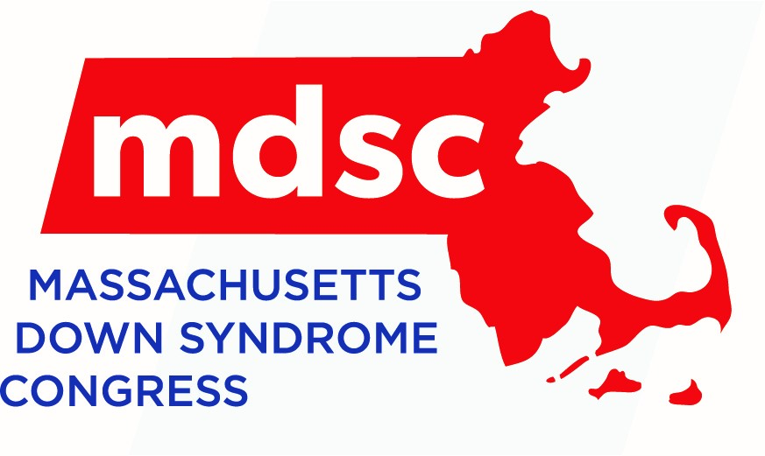

The Massachusetts Down Syndrome Congress (MDSC) and the Boston Children’s Hospital Down Syndrome Program are co-hosting a quarterly support group for families of children with Down syndrome and special health care and/or
behavioral needs.

Parents, please join us for a Zoom to connect with others, feel supported and share what you would like from this group (virtual/in-person meetings, speakers, resources, peer-to-peer support, etc.)

Saturday, April 27 from 9 – 10:30 AM
With Angela Lombardo, LICSW and Sarah Cullen

Please pre-register HERE so we can send friendly reminders closer to the meeting!

Or email Sarah Cullen at scullen@mdsc.org or Angela Lombardo at angela.lombardo@childrens.harvard.edu for more information!

We are here for you!

