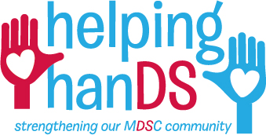

e-Toolkit for a Successful Community Fundraiser

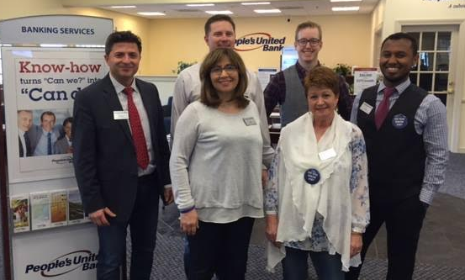

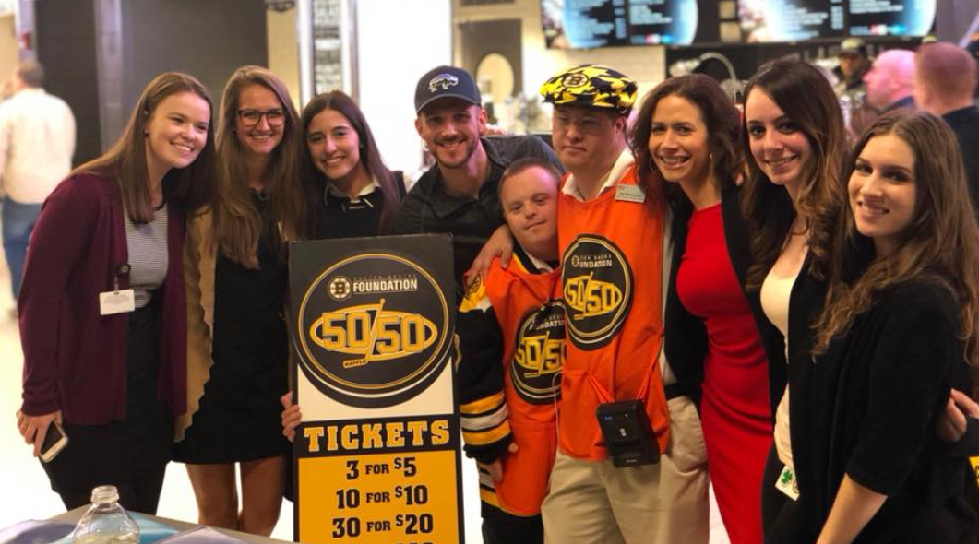

On behalf of everyone at the MDSC, thank you for your desire and willingness to help support our mission to ensure all individuals with Down syndrome are valued and included! We hope that you will find the enclosed information helpful for your community fundraiser event and stand ready to serve as your resource throughout the planning process. Thank you for being an important friend of the MDSC!

e-Toolkit - Table of Contents

- How-To
  - What is a community fundraiser
  - Examples of community fundraisers
  - How the MDSC will support you
  - Steps to get started

- Community Fundraiser guidelines

- Fundraising tips

  - Planning
  - Asking
  - Follow-through

- Solicitation template

- Thank you template

- Press template

- MDSC and Buddy Walk logos

How-To

What is a community fundraiser?
A community fundraiser, also known as a “third party fundraiser,” is any fundraising initiative brought forward by an individual or group external to the charitable organization which it benefits. The fundraiser is planned, managed, and financially resourced by the individual host.

If you have the desire to help raise funds for the MDSC, we can help you leverage an existing event or work with you on a fundraising idea that you’re passionate about.

Examples of Community Fundraising Events:
- Bake sale
- Benefit concert
- Bowl-a-thon
- Car wash
- Coin drive
- Dress-down day
- Fitness class
- Golf outing
- Lemonade stand
- Special occasions: ask guests to donate in lieu of gifts for a birthday, graduation, wedding, bar/bat mitzvah, etc.
- Sports tournament
- Yard sale
- For interest in a running, walking, or other endurance event, check out our Race for MDSC program: mdsc.org/events/RaceforMDSC

How the MDSC will support you:
- Serve as your resource, on-call to answer your questions and offer advice on event planning and fundraising
- Send you a custom Helping Hands toolkit (electronic and via mail)
- Provide an official MDSC endorsement letter to validate the authenticity of your efforts
- Provide banners, brochures, and other promotional items for your event
- Give access to our name and logo for your marketing materials
- Set up a personal fundraising page
- Provide a MDSC singlet for running or other endurance events

Get Started!
- Contact Ali Haydock at rbik@mdsc.org or 781-221-0024 x 205 to register
- You will receive an electronic Helping Hands toolkit via email: a guide full of resources to help ensure your event is a success, including email and letter templates, fundraising tips, and guidelines.
- You will also receive a Helping Hands toolkit in the mail, complete with official Helping Hands t-shirt, water bottle, and other goodies to help brand your event.

Community Fundraising Guidelines

- All organizers must complete the MDSC Community Fundraising Application
- Fundraisers should complement the mission of the Massachusetts Down Syndrome Congress (MDSC)
- The Massachusetts Down Syndrome Congress can only be identified as the beneficiary
  - Correct messaging to utilize: Annual Buddy Ride benefiting the Massachusetts Down Syndrome Congress
  - Incorrect messaging: Massachusetts Down Syndrome Congress Annual Buddy Ride
- The MDSC reserves the right to request additional information before approving a fundraiser
- The organizer is responsible for obtaining any permits and a certificate of insurance if required by local, state, and federal laws
- The organizer is not permitted to open a bank account in the name of the MDSC
- The organizer is responsible for covering all expenses up front, and the MDSC does not provide reimbursement for any losses incurred. Expenses can be paid back out of the proceeds before sending the final donation to the MDSC
- The MDSC strongly encourages expenses to not exceed 50 percent
- Upon approval, you will have authorization to use the MDSC name and logo on all of your marketing pieces. The MDSC must review all pieces that have the MDSC name and logo before it’s printed, distributed, or made available online.
- All proceeds need to be made payable to the MDSC and mailed within 30 days of your fundraiser. Please don’t send in cash.
- The MDSC will issue IRS-compliant charitable tax receipts to the full extent of the law if the gift is made payable directly to the MDSC. When conducting a silent or live auction, the fair market value must be disclosed. The MDSC can only issue IRS-compliant tax receipt if the amount paid is beyond the fair market value and if the payment is made directly to the MDSC
- The MDSC reserves the right to decline approval or withdraw as beneficiary at any time if we feel there is a conflict of interest or the fundraiser no longer aligns with MDSC standards.

Fundraising Tips:
- PLANNING:
  - Make a list of potential supporters. Think creatively; include friends, family, co-workers, neighbors, people/companies you do business with, places you frequent, etc.
  - Set a goal. Be aspirational to inspire yourself and your donors. If you are approaching the goal, don’t be afraid to raise it.

- ASKING:
  - Solicit in a variety of ways. Consider using email, handwritten letters, phone calls, and face-to-face interaction. Follow up using a different mode of communication.
  - Tell a story. Sharing a personal message makes your appeal more compelling. The more personal your outreach, the better. Use photos and even videos whenever possible.
  - Keep your donors informed. Update them on your success as you approach your goal. Social media can be a great tool for sharing your progress.
  - Letters should be donor-centric. Make sure your donors know what their donation will go toward and how they can help.
  - Don’t forget to include a self-addressed and stamped envelope with your letter. Including a return envelope will greatly increase the chances that your donors will make a contribution. Make it easy for them to give!
  - Make sure someone signs the letter. A personalized, hand-signed letter adds professionalism and a personal touch.

- FOLLOW-THROUGH:
  - Thank your donors. Send thank you notes and emails to all of your supporters. This will make them feel appreciated and help ensure that they donate again.
  - Follow up. After you’ve achieved your goal and held your community fundraiser, report back in with donors to share what happened and how their funds made a direct impact.

Solicitation Template

Your name
Your address

Date

Recipient name
Recipient address

Dear Salutation,

Begin with an emotional appeal or success story to draw the reader in. Try to make this personal and compelling.

The mission of the MDSC is to ensure individuals with Down syndrome in Massachusetts are valued, included, and given the opportunities to pursue fulfilling lives. By providing advocacy, resources, support, and networking opportunities for individuals with Down syndrome and their families, health care professionals, and the community, the MDSC aims to improve the quality of life for individuals with Down syndrome.

With your support, the MDSC can offer a wide-range of programs that serve and improve the lives of people with Down syndrome and their families throughout the state. These programs include The Parents First Call program, which offers support to expectant and new parents; two major conferences annually that draw participants from across New England; Teen and Adult programs which connect and empower peers with and without disabilities; The MDSC Buddy Walk Program which gives individuals, schools, community groups, and local businesses across the state an opportunity to get involved in fundraising campaigns and events year-round; services and programs for health care professionals; legislative advocacy; and much more.

RECIPEINT NAME, I hope you will consider partnering with me in support of the important mission of the MDSC by making a gift of $AMOUNT. By supporting this organization which means so much to me, you are bettering the lives of countless individuals with Down syndrome, like NAME OF PERSONAL CONNECTION TO DS (if applicable). I am incredibly grateful for your consideration of this request.

Sincerely,
YOUR NAME

Thank You Templates

Version 1:

Dear NAME,

Thank you very much for your generous donation of $AMOUNT to support my fundraising efforts for the Massachusetts Down Syndrome Congress.

Your gift directly supports the work of the MDSC to ensure that all individuals with Down syndrome are valued, included, and given opportunities to pursue meaningful lives in the community.

I look forward to updating you on my progress as I continue to strive for my goal to raise $AMOUNT for the MDSC.

With appreciation,
YOUR NAME

----------------------------------------------------------------------------------------------------
Version 2:

Dear NAME,

Thanks to your support, the Massachusetts Down Syndrome Congress is able to offer a broad array of programs and services to individuals with Down syndrome and their families. The MDSC supports individuals across their lifespan, with programs like Parents First Call for new and expectant parents, Advocates in Motion which empowers and connects teens and adults, and everything in between.

Without your generosity, the MDSC would not be able to pursue its mission to ensure individuals with Down syndrome in Massachusetts are valued, included, and given the opportunities to pursue fulfilling lives. Please accept my sincere appreciation for partnering with me in helping the MDSC to serve as the leading Down syndrome resource in the state. It is truly meaningful to me and makes a profound impact on the life of PERSONAL CONNECTION TO DS (if applicable). EXPAND ON/INSERT PERSONAL STORY/CONNECTION TO DOWN SYNDROME.

Thank you,
YOUR NAME

Press Template - Get the word out about your fundraising efforts!

Include the below elements:

- When the press release can be shared (usually this will read “For Immediate Release”)

- Headline (such as, “Birthday gifts directed to help individuals with Down syndrome” or “Golf Tournament raises funds for Down syndrome community”)

- Organization information:
Massachusetts Down Syndrome Congress
20 Burlington Mall Road, Suite 261
Burlington, MA 01803
781-221-0024
www.mdsc.org

- Your information:
Name
Phone number
Email address

- Place, day, time of event

- Short description of event, including number of participants, funds raised, activity, next steps, etc.

- Information about the MDSC:
The mission of the MDSC is to ensure individuals with Down syndrome in Massachusetts are valued, included, and given the opportunities to pursue fulfilling lives by providing information, networking opportunities, and advocacy for people with Down syndrome and their families, educators, health care professionals, and the community-at-large.

- Repeat your contact information

- Repeat event information

- ### (these characters signal the end of the release)

MDSC Logos

Simply copy and paste these images into your marketing flyers and communications to add legitimacy to your efforts!

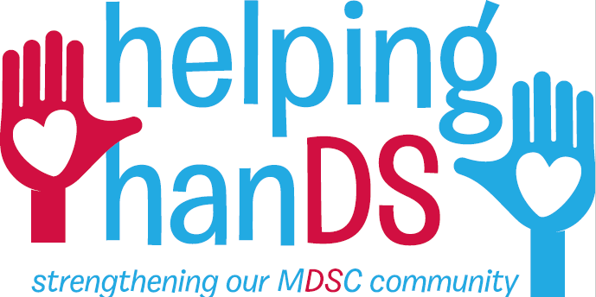

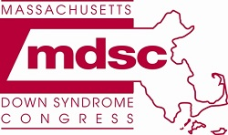

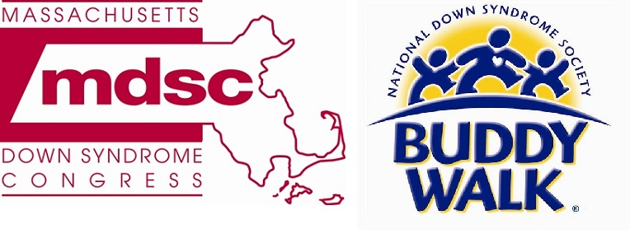

Thank you for supporting the MDSC!

